A MEDIATING PLATFORM FOR JOB SEEKERS

AND TALENT ACQUISITION MANAGERS

ICS1261- Software Development and Practice using Python

A PROJECT REPORT

Submitted By

JAYASREE R 3122237001019

JOICE ANANCIA S A 3122237001020

MOOGAMBIGAI A 3122237001027

5-Year Integrated M.Tech

Computer Science and Engineering

Sri Sivasubramaniya Nadar College of Engineering

(An Autonomous Institution, Affiliated to Anna University)

Kalavakkam – 603110

June 2024

**Sri Sivasubramaniya Nadar College of Engineering**

**(An Autonomous Institution, Affiliated to Anna University)**

**BONAFIDE CERTIFICATE**

Certified that this project report titled “ A mediating Platform for Job seekers and Talent acquisition Managers” is the bonafide work of “ JAYASREE R (3122237001019) JOICE ANANCIA S A (3122237001020) MOOGAMBIGAI A (3122237001027) ” who carried out the project work in the ICS1261- Software Development and Practice using Python during the academic year 2023-24.

Internal Examiner External Examiner

Date:

|  |  |  |
| --- | --- | --- |
| **Sno** | **TABLE OF CONTENTS** | **Pg no** |
|  | Abstract | 4 |
| 1. | Problem Statement | 4 |
| 2. | Extended exploration of problem statement | 4 |
| 3. | Analysis using UML Diagrams | 5-7 |
| 4. | Detailed Design | 8-14 |
| 5. | Description of each Module | 15 |
| 6. | Implementation | 16 |
| 7. | Validation through Detailed Test cases for various scenarios | 17-30 |
| 8. | Limitations of the solution provided | 30-31 |
| 9. | Observations from the Societal, Legal, Environmental andEthical perspectives | 31-32 |
| 10. | Learning Outcomes | 32-33 |
| 11. | References | 33 |

**ABSTRACT**

The project, "A Mediating Platform for Job Seekers and Talent Acquisition Managers," aims to replicate the process of matching job seekers with recruiters, similar to the systems used by many online recruitment platforms. This project is important because it helps us understand the complex job matching process by simulating real-world recruitment scenarios.

By exploring these processes in detail, the project seeks to improve the connection between job seekers and talent acquisition managers, making recruitment more efficient and effective. This simulation not only helps us understand how job matching works but also serves as a useful tool for both academic research and practical use in human resource management.

**1. Problem Statement**

To create a mediating platform through which:

i. Job seekers can explore open positions that match their profiles.

ii. Talent acquisition managers can search for deserving applicants who meet their job requirements.

**2. Extended exploration of problem statement**

This project addresses the need for an efficient platform that connects job seekers and talent acquisition managers, streamlining the recruitment process.

For job seekers, the platform offers a personalized job search experience. It matches job seekers with positions that align with their skills, experiences, and career goals. This approach saves time and increases the likelihood of finding suitable employment.

For talent acquisition managers, the platform provides powerful tools to identify and evaluate candidates. Recruiters can set specific criteria to find applicants who meet their job requirements, thus reducing recruitment time and effort while allowing focus on strategic hiring decisions. The platform also offfers a personalized search for employees.

By simulating real-world recruitment scenarios and integrating innovative features, this project offers valuable insights into the hiring process. It aims to revolutionize the connection between job seekers and talent acquisition managers, leading to more effective recruitment outcomes.

**3. Analysis using UML Diagrams**

3.1. **Use case Diagram :**

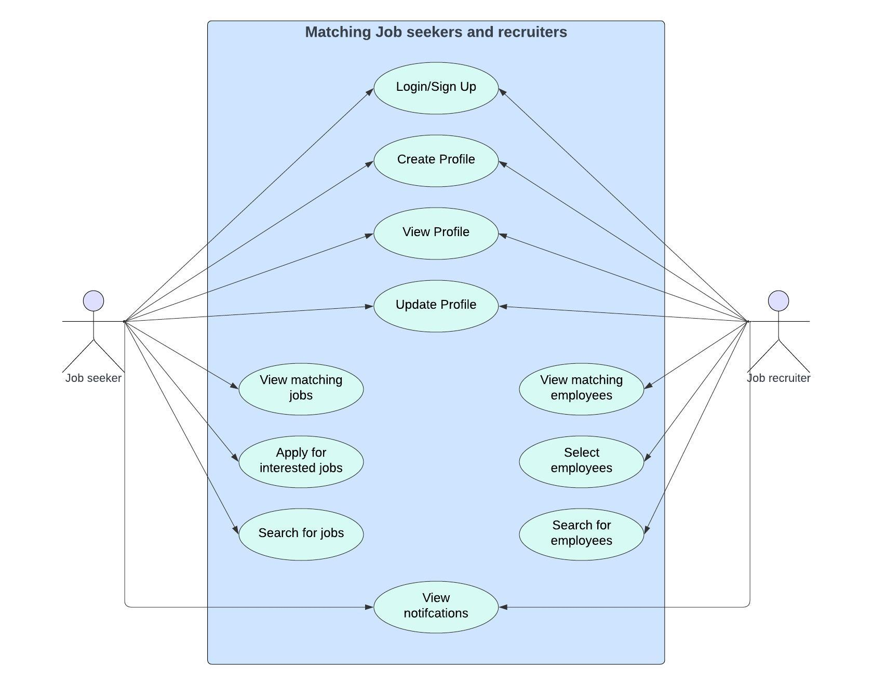

**3.2 Sequence Diagram**

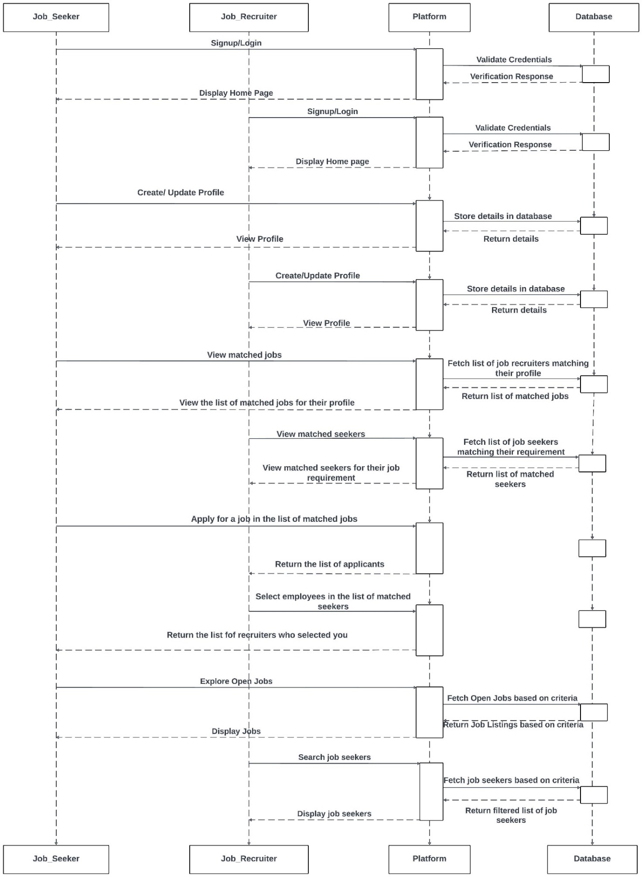

**3.3 Class Diagram**

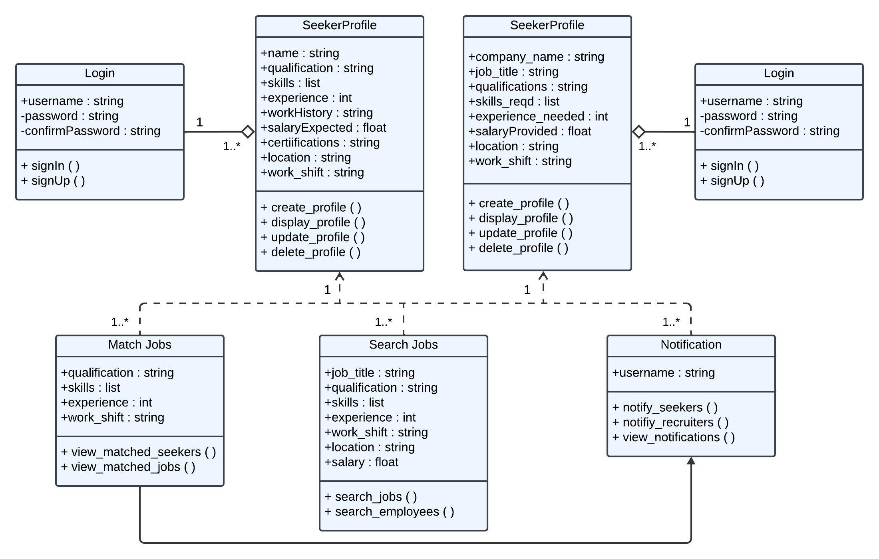

**4. Detailed Design :**

**4.1 Architecture Diagram :**

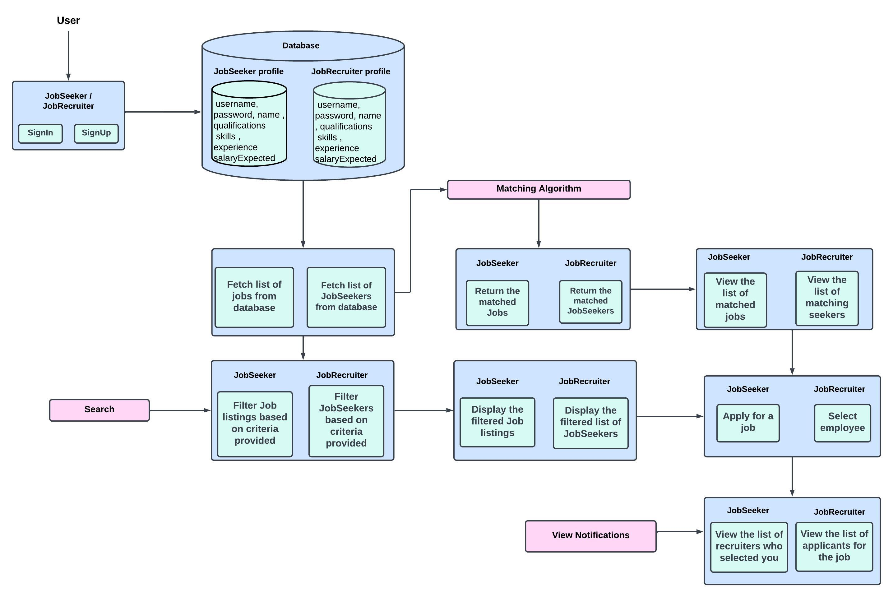

**4.2 Flowcharts**

**4.2.1 Login Page**

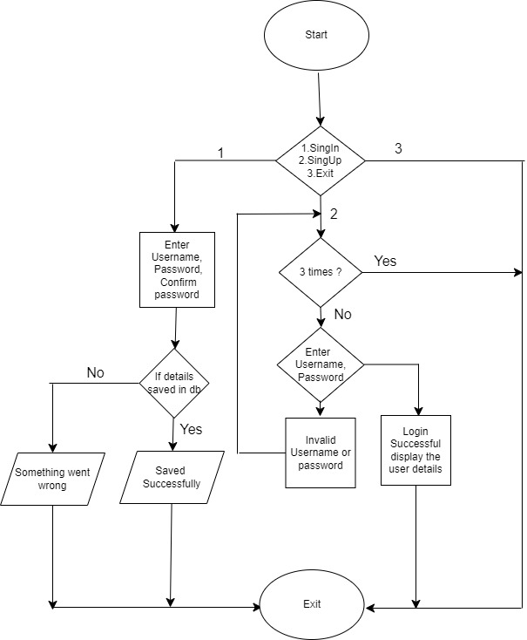

**4.2.2 Profile Management**

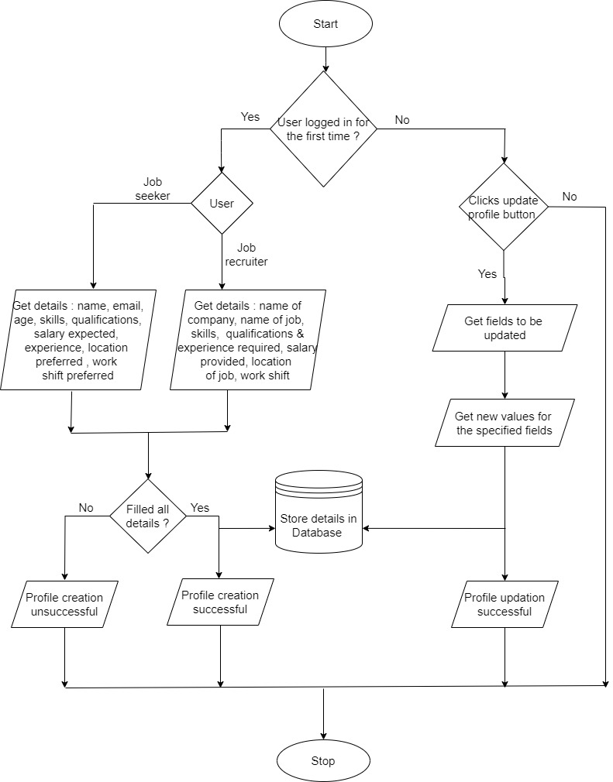

**4.2.3 Match Jobs**

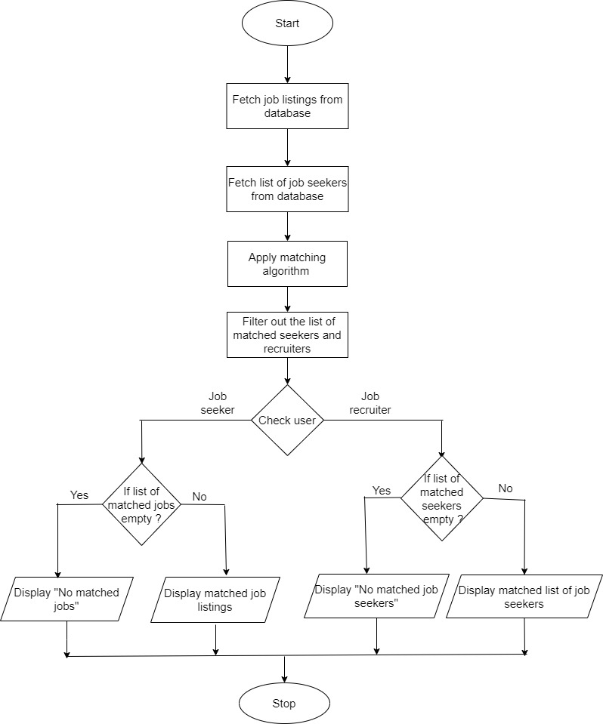

**4.2.4 View matched jobs**

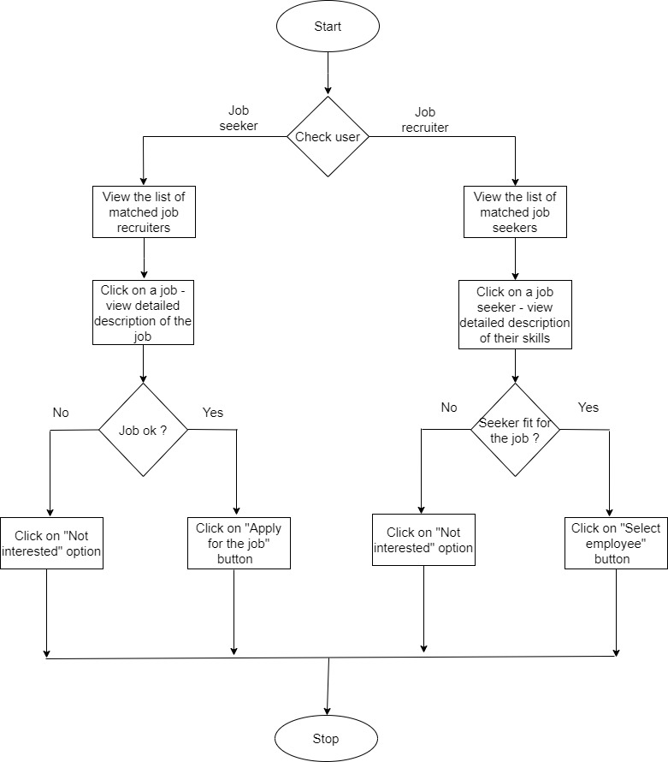

**4.2.5 View Notifications**

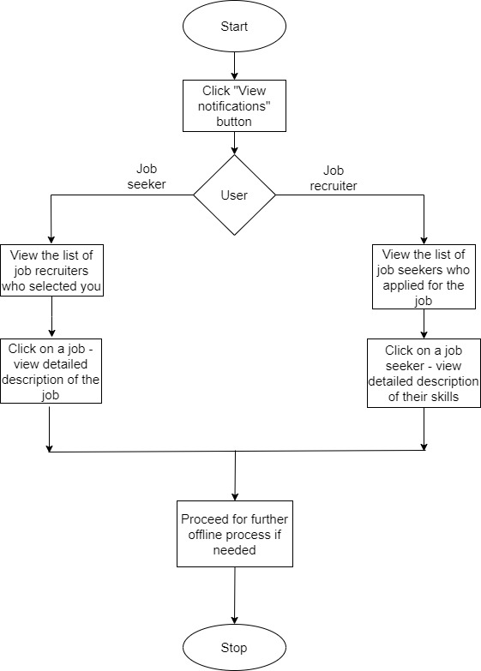

**4.2.6 Search**

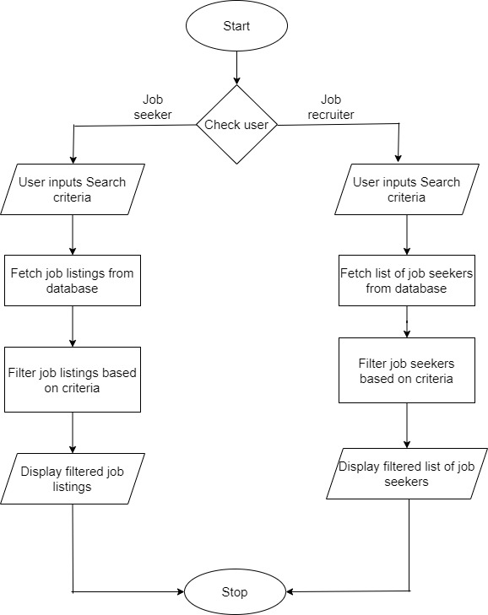

**5. Description of Each Module**

**5.1. Login (inside login_page.py):**

* **SignIn()**: Prompts users to enter their username and password to access their accounts.
* **SignUp()**: Allows new users to create an account by entering a username, password, and confirming the password.

**5.2. Job Seeker Profile Management (inside seeker_profile.py):**

* **create_profile()**: Enables job seekers to create a new profile by providing their personal and professional information.
* **display_profile()**: Displays the job seeker's profile information.
* **update_profile()**: Allows job seekers to update their profile details.
* **delete_profile()** : Allows job seekers to permanaently log off from the platform

**5.3. Recruiter Profile Management (inside recruiter_profile.py):**

* **create_profile()**: Enables recruiters to create a new profile with their company and contact details.
* **display_profile()**: Displays the recruiter's profile information.
* **update_profile()**: Allows recruiters to update their profile details.
* **delete_profile()** : Allows job recruiters to permanaently log off from the platform

**5.4. Matching Algorithm (inside match.py):**

* **view_matching_jobs()**: Job seekers can view job listings that match their profiles.
* **view_matching_seekers()**: Recruiters can view job seekers who match their job requirements.

**5.5. Search Jobs (inside search_jobs.py):**

* **search_jobs()**: Job seekers can search for job openings based on various criteria.
* **search_employees()**: Recruiters can search for potential employees.

**5.6. Notifications (inside notifications.py):**

* **notify_seekers()**: Sends notifications to job seekers about the job recruiters who had selected them .
* **notify_recruiters()**: Sends notifications to recruiters about the job seekers who had applied for their job

**5**.7. FAQ (inside faq.py ):

* **view_faqs()**: Allows users to see the frequently asked questions related to that job and also allows them to ask questions.

**6. Implementation**

**Data Organization and Rationale:**

* **Lists**: Used for storing temporary data such as search results.
* **Dictionaries**: Employed to store user profiles and job listings, providing efficient key-value pair lookups.
* **Files**: Utilized for storing frequently asked quetsions
* **Image Files** : For storing the profile pictures of seekers and company logos of recruiters.

**Libraries and APIs:**

* **Django**: Framework used for building the web application. Functions like render and redirect facilitate webpage rendering and URL redirection, respectively.
* **SQLite3** : Database system used to store user data, job listings, and other relevant information. It ensures robust data management and retrieval capabilities.
* **Messages**: Django’s messaging framework to display one-time notifications to users about the success or failure of actions.

**User Interface Design:**

* Designed to be intuitive and user-friendly, ensuring a seamless experience for both job seekers and recruiters.
* Forms and input fields are designed for easy data entry.
* Notifications are displayed prominently to keep users informed of updates.

**Platform Used for Code Development:**

* **VS Code**: Chosen for its robust features like IntelliSense, debugging capabilities, and a vast array of extensions.

**7. Validation through Detailed Test cases for various scenarios**

**Output Screenshots :**

**Welcome page :**

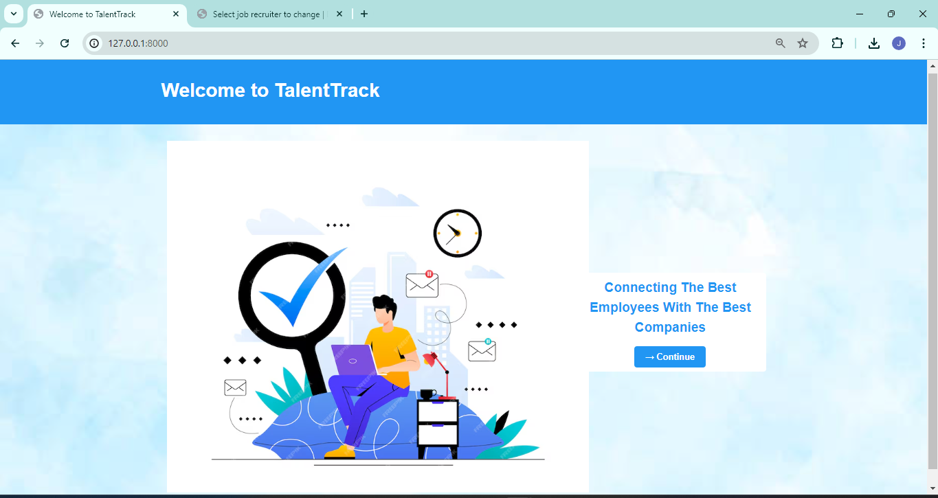

**Signup Page :**

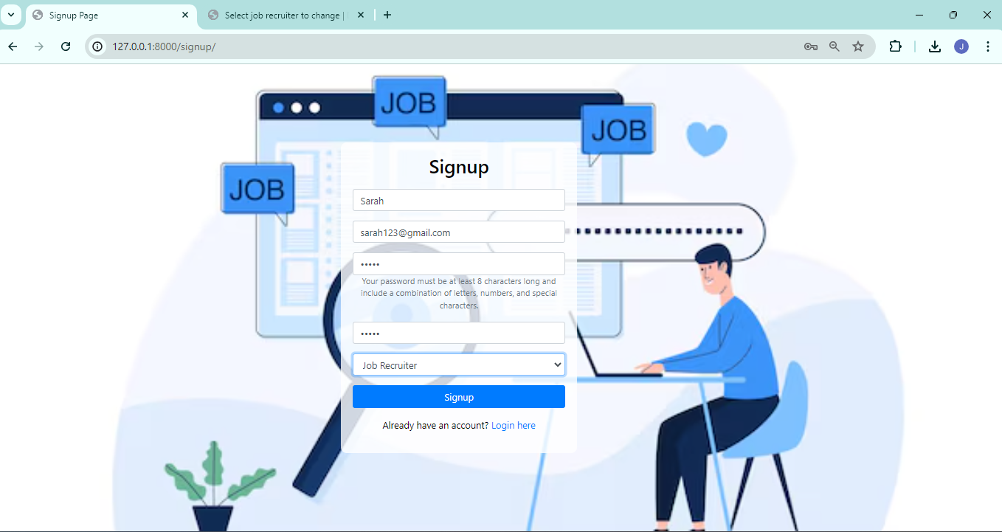

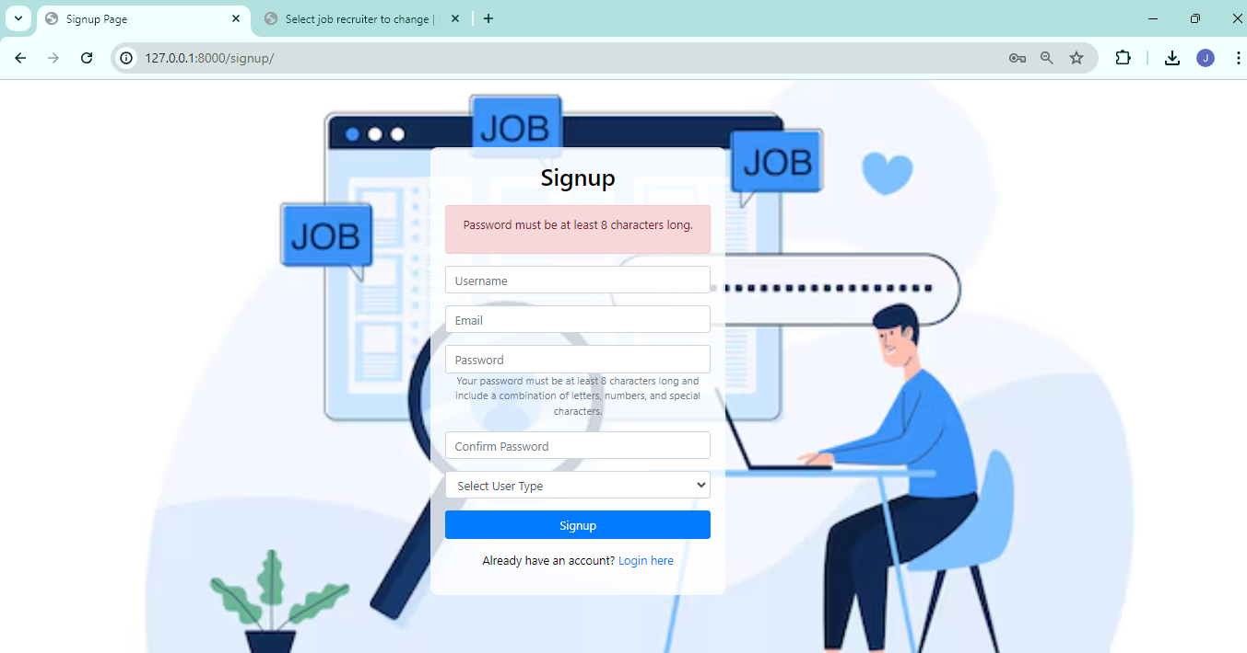

**(appropriate validations are handled)**

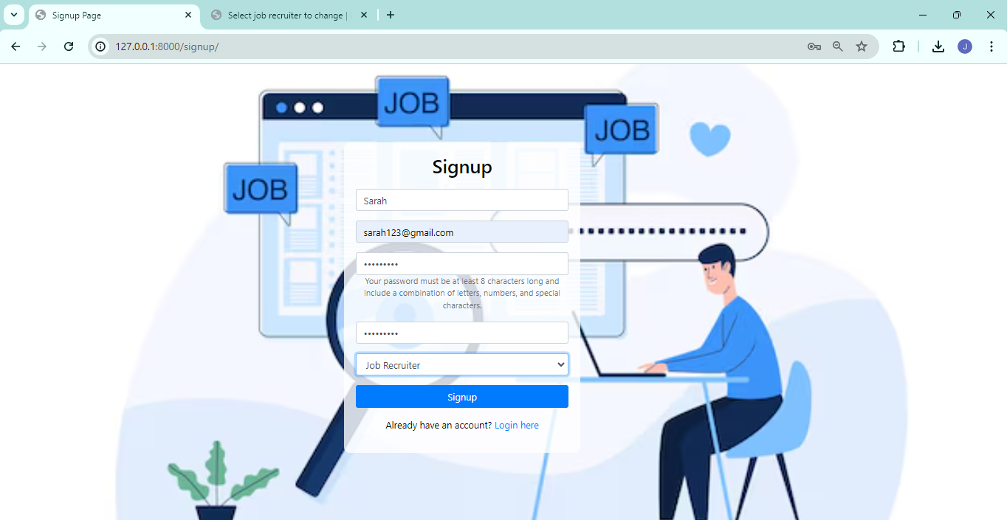

**For Job Recruiters :**

**Profile Creation :**

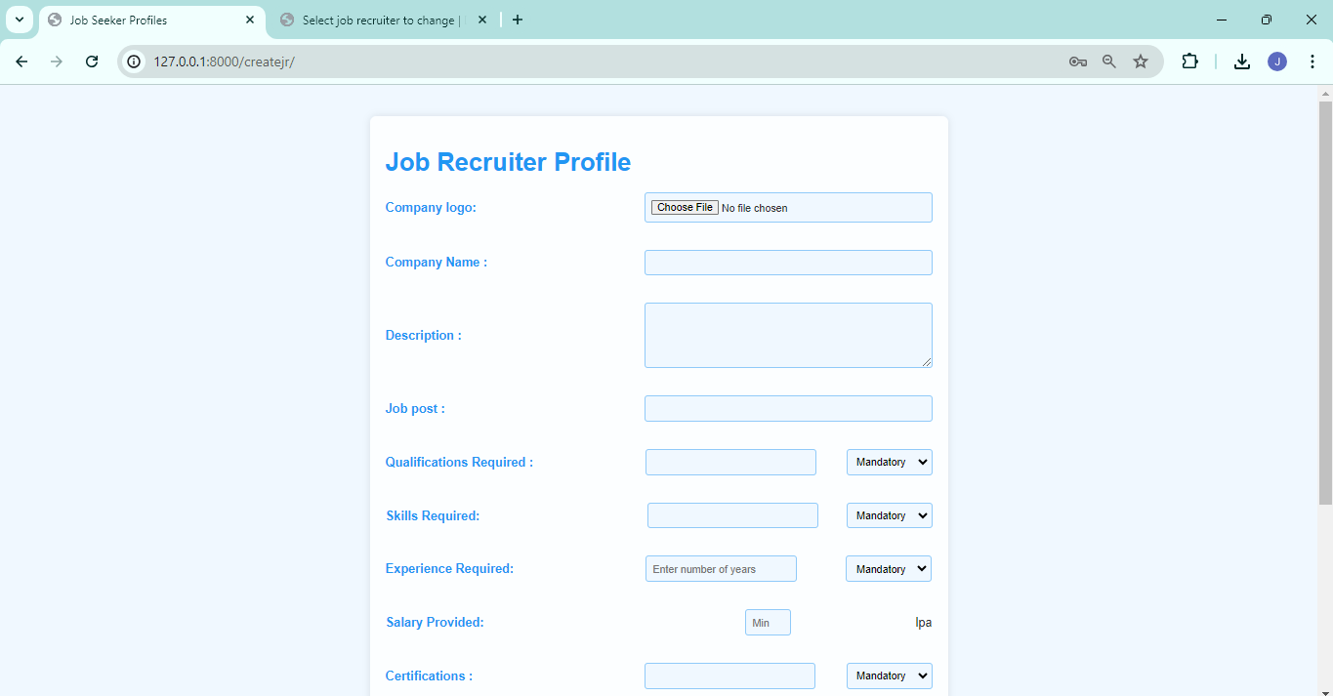

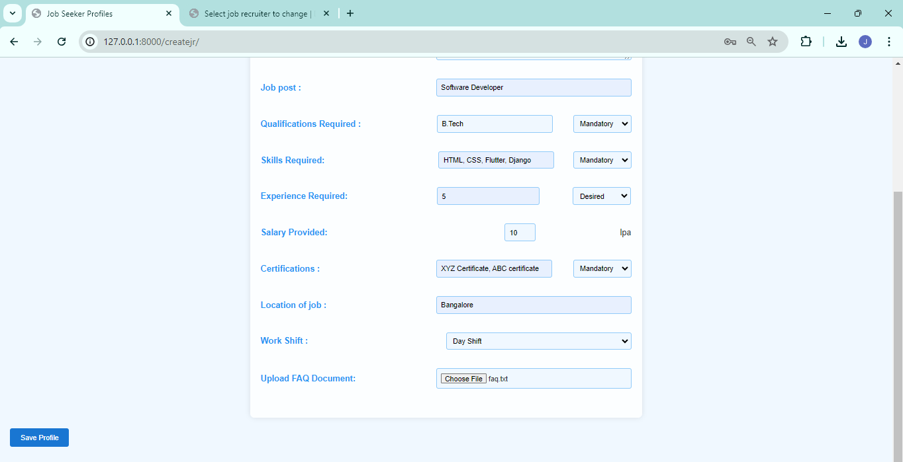

Home Page :

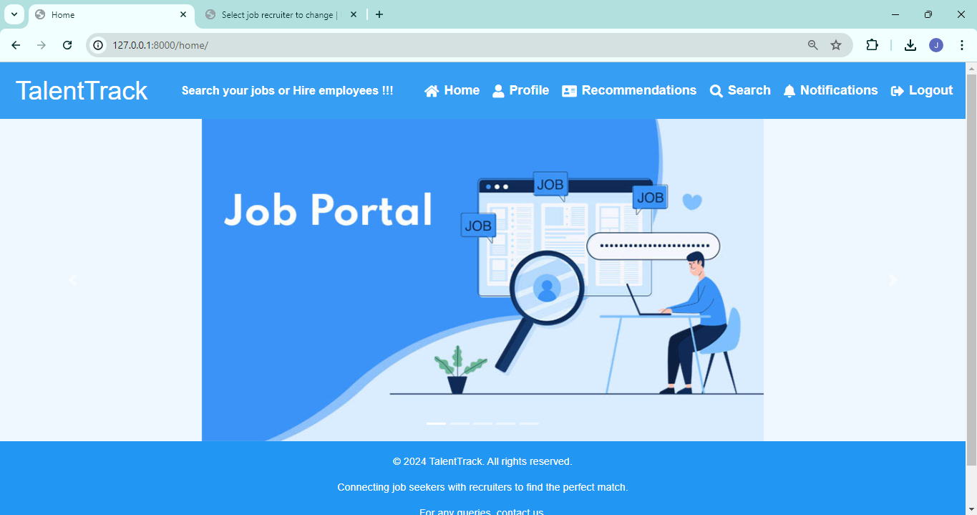

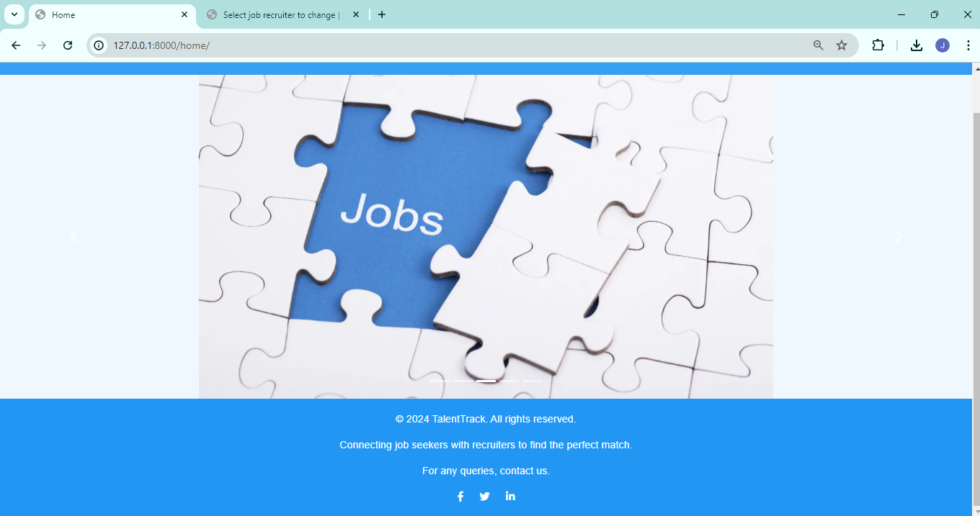

**Profile page :**

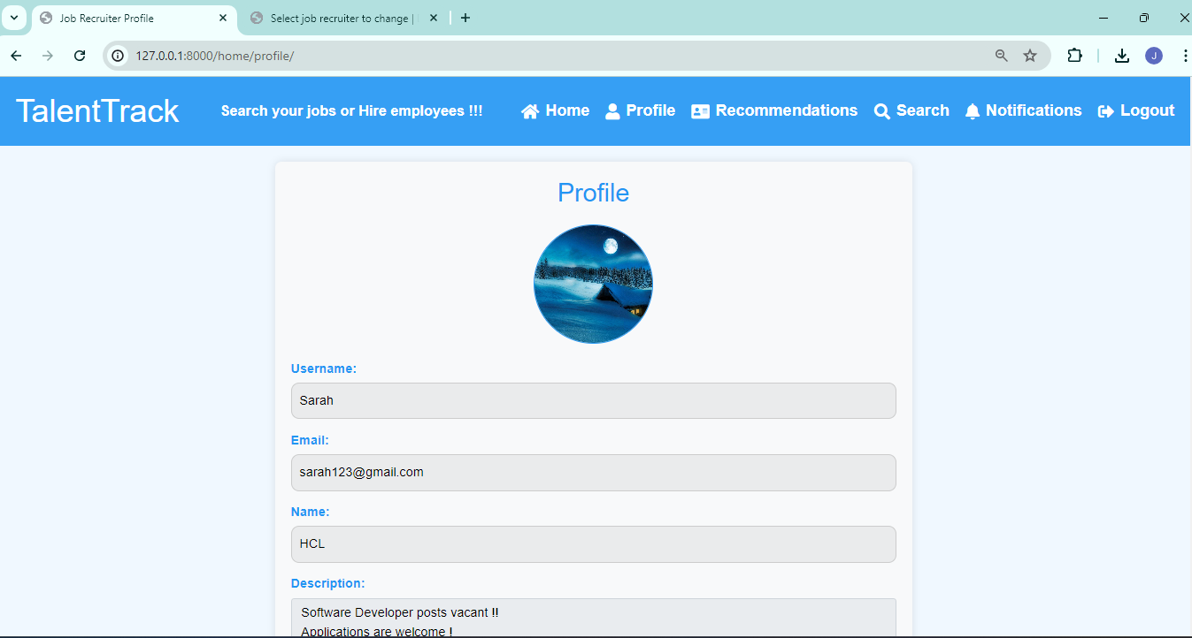

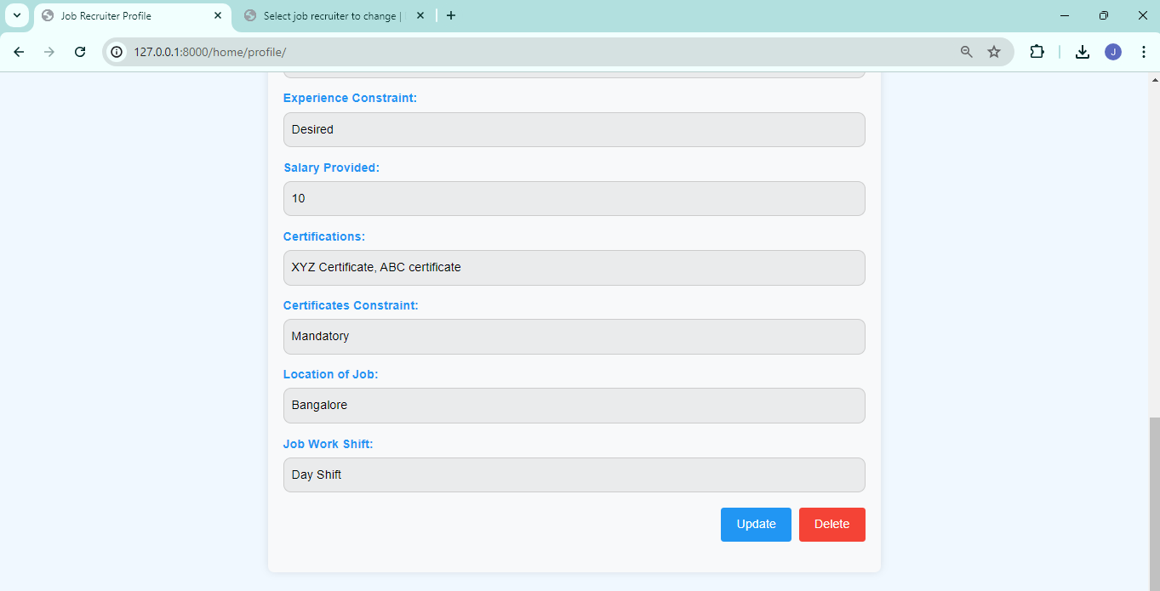

**Update Profile :**

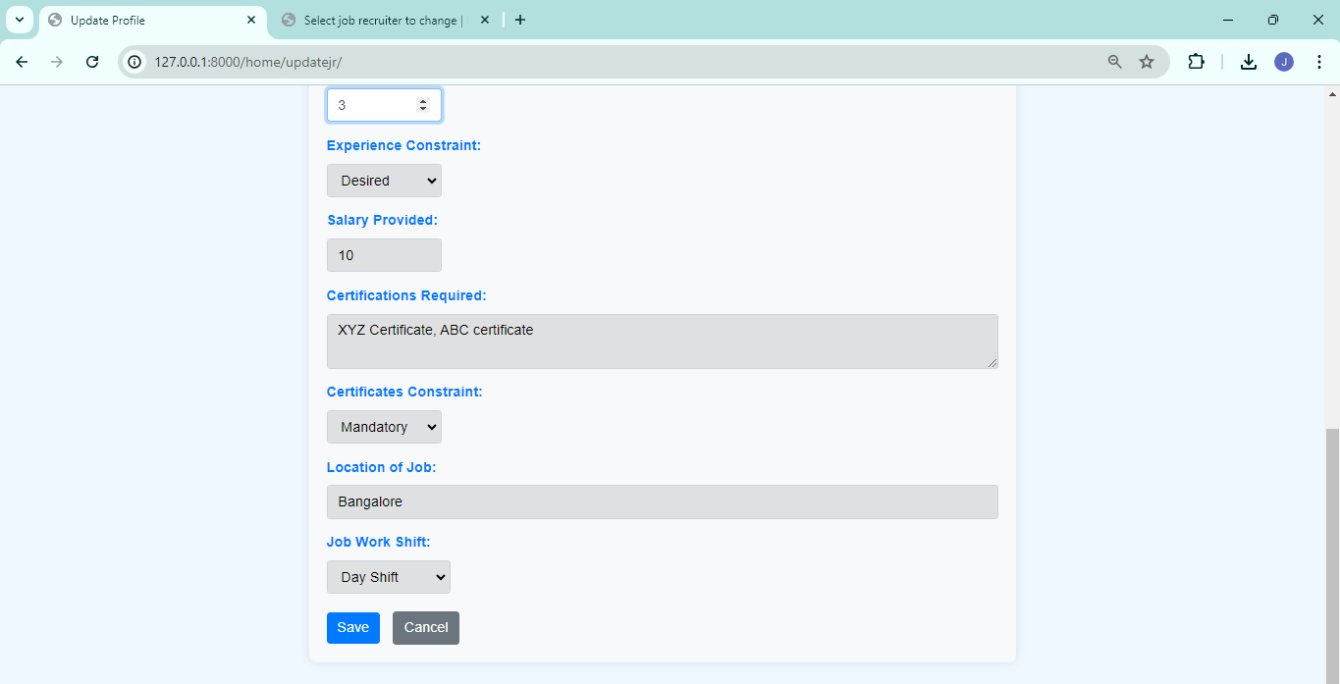

**Recommendations :**

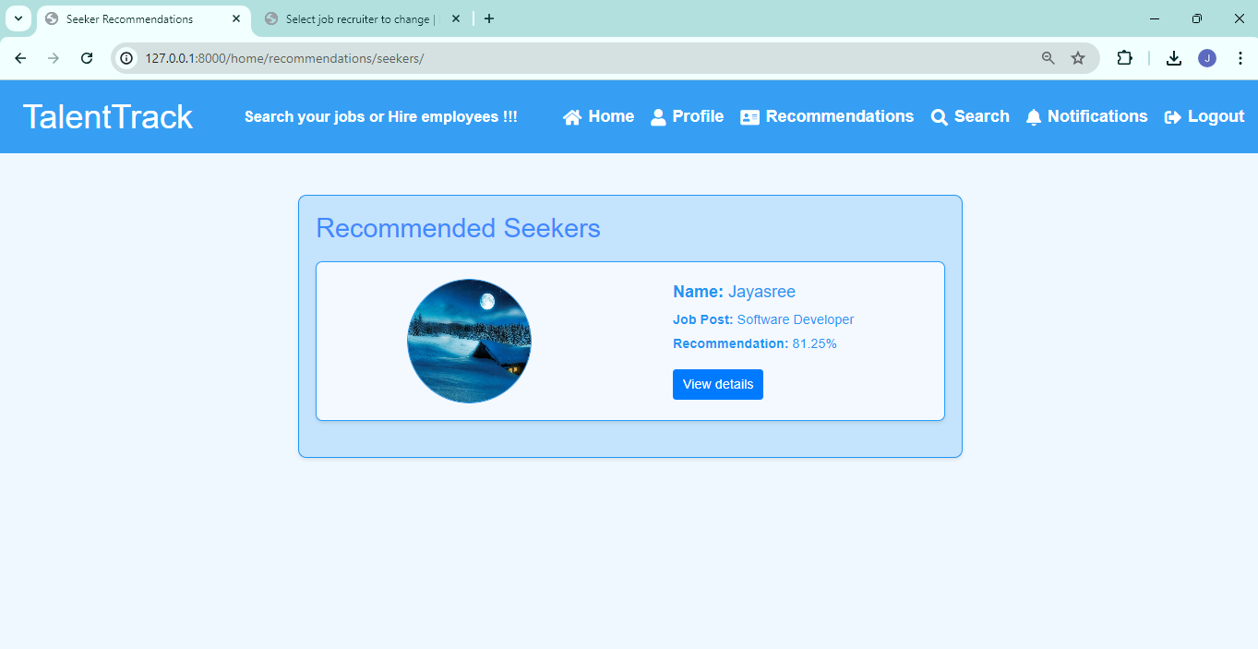

**View details :**

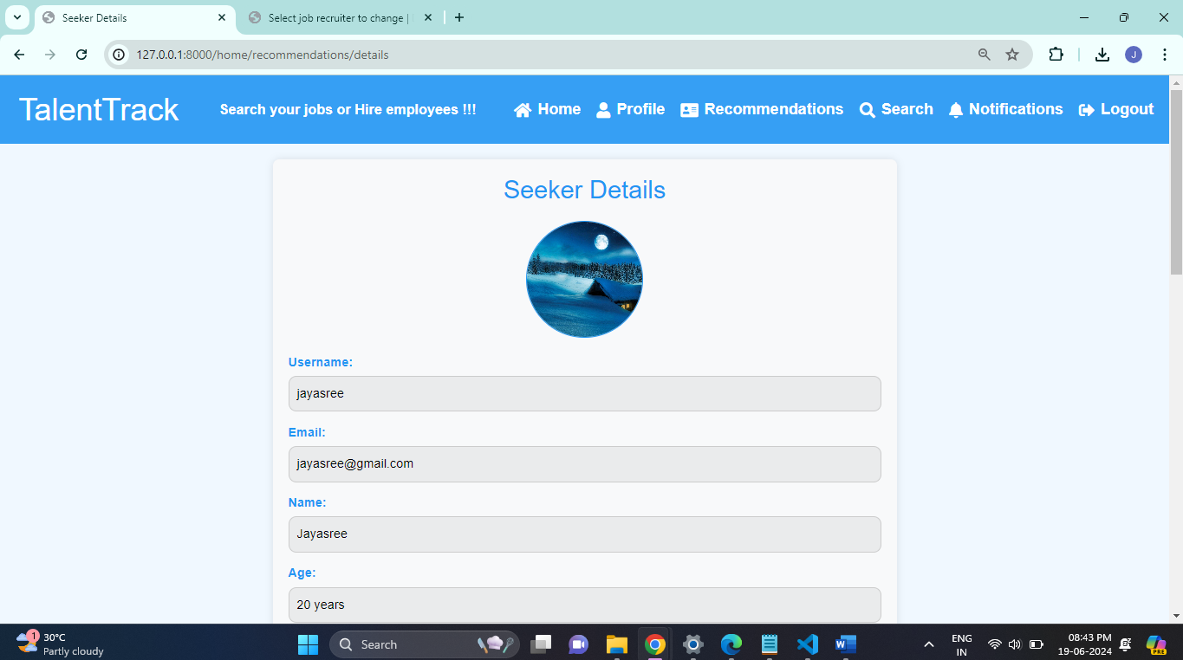

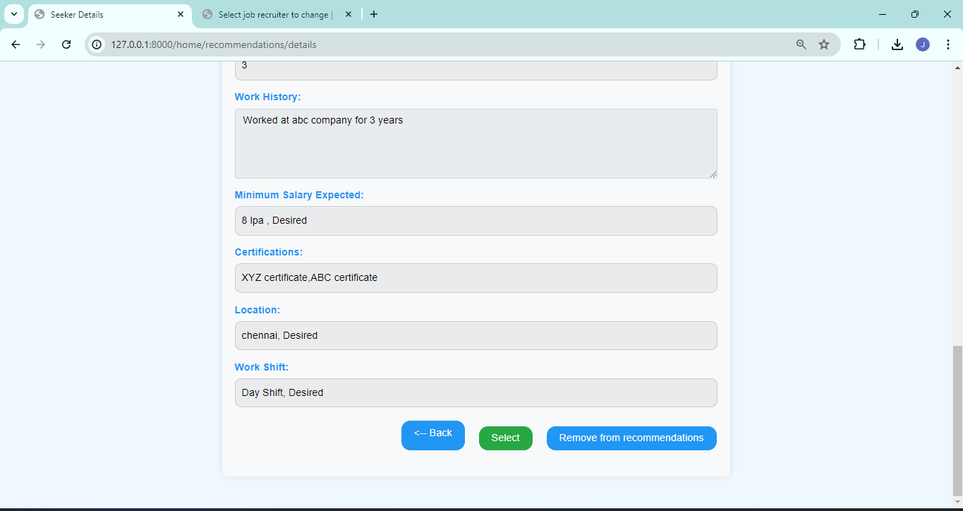

**Search seekers :**

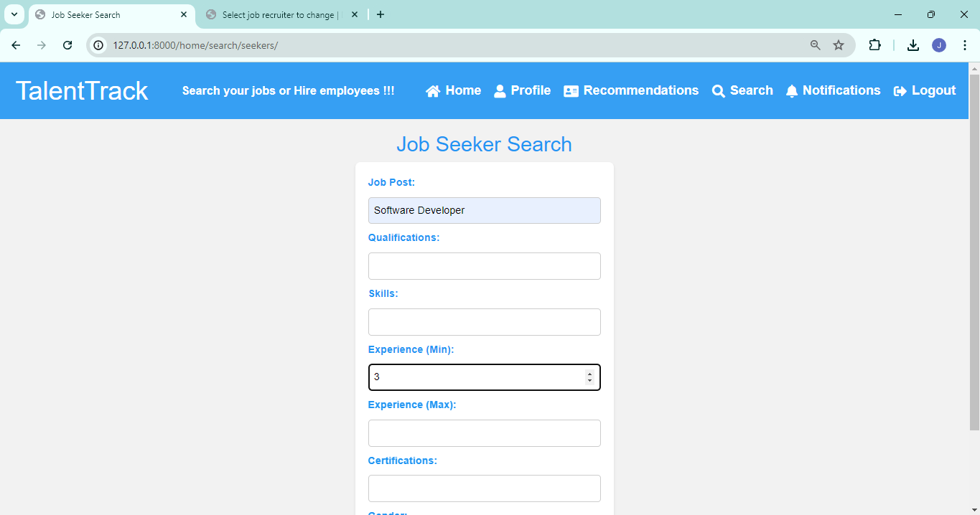



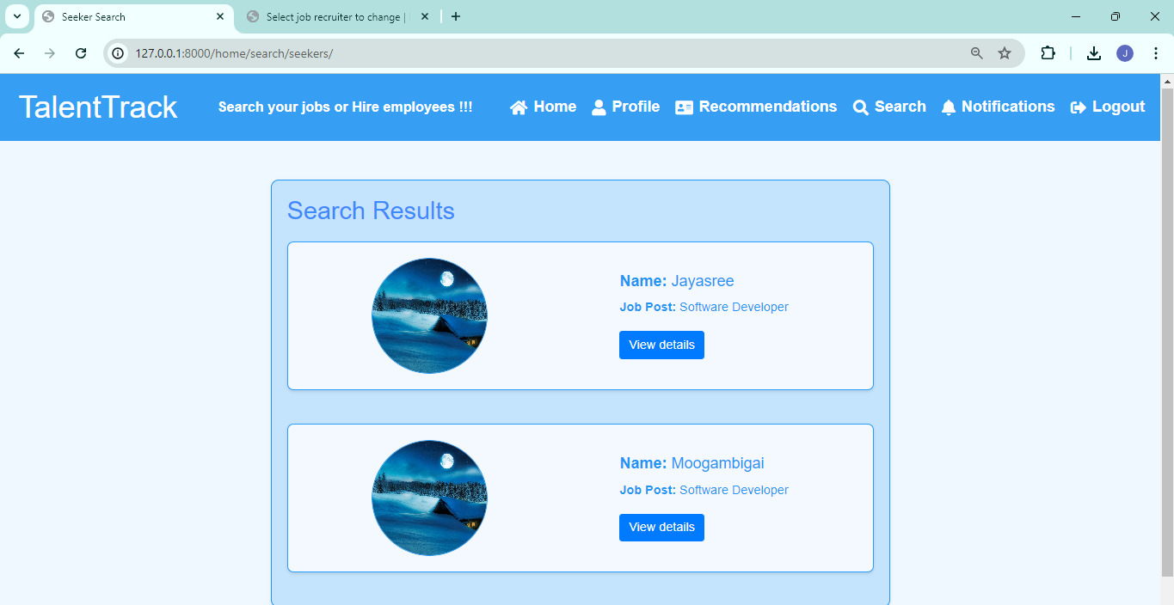

**For Job seekers :**

**Signup :**

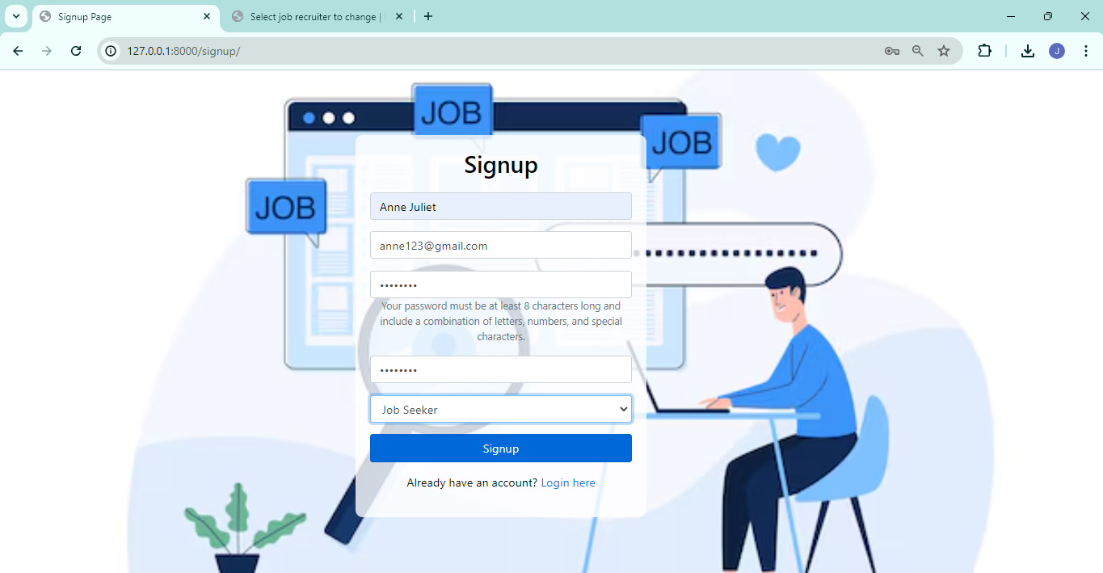

**Profile Creation :**

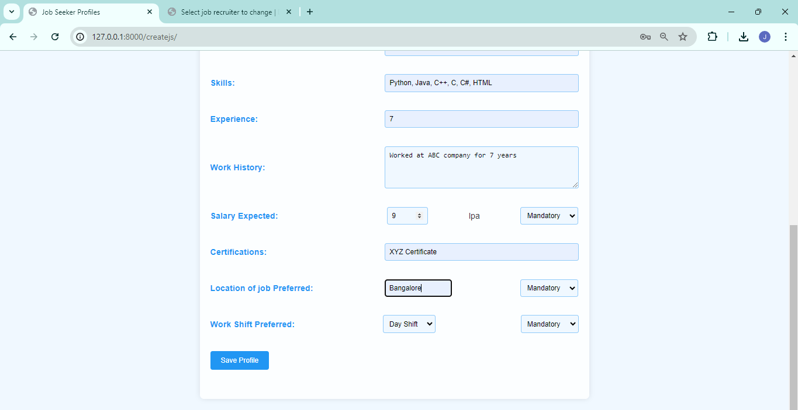

Profile Page :

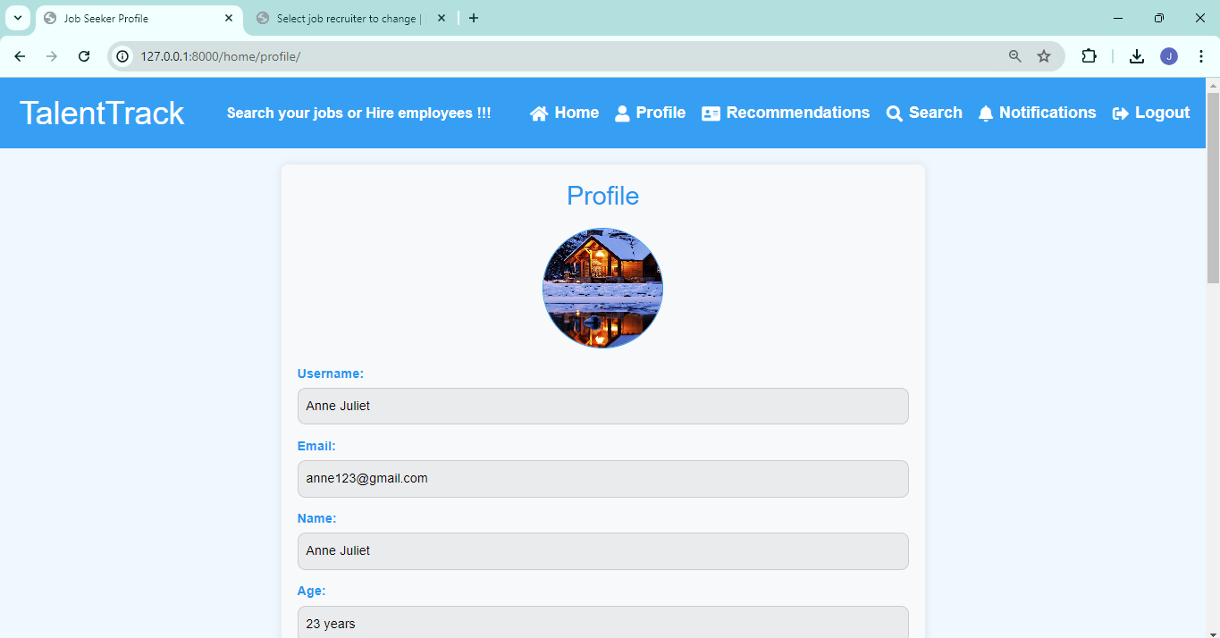

Update and delete Profiles :

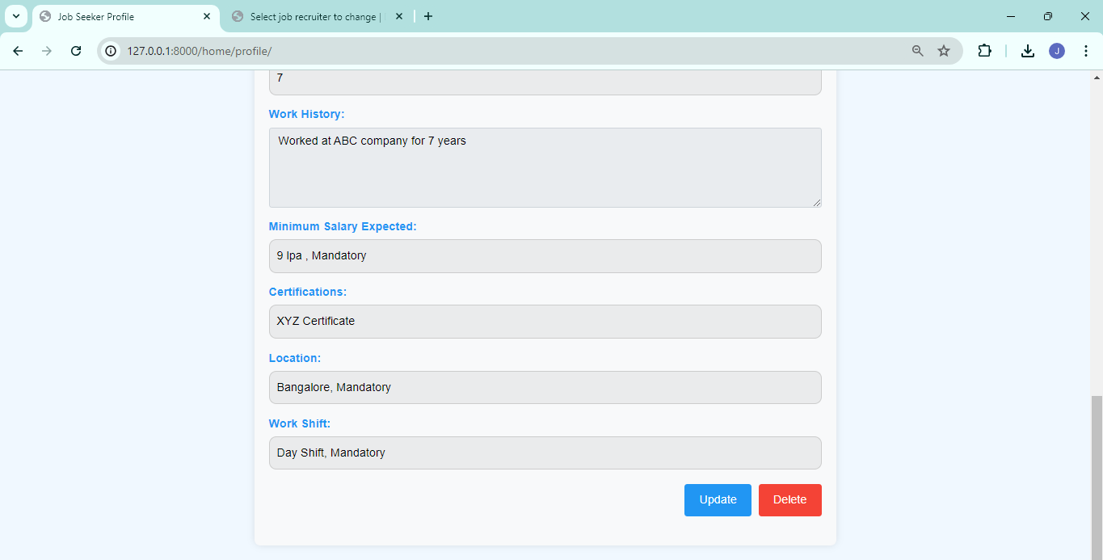

Recommendations :

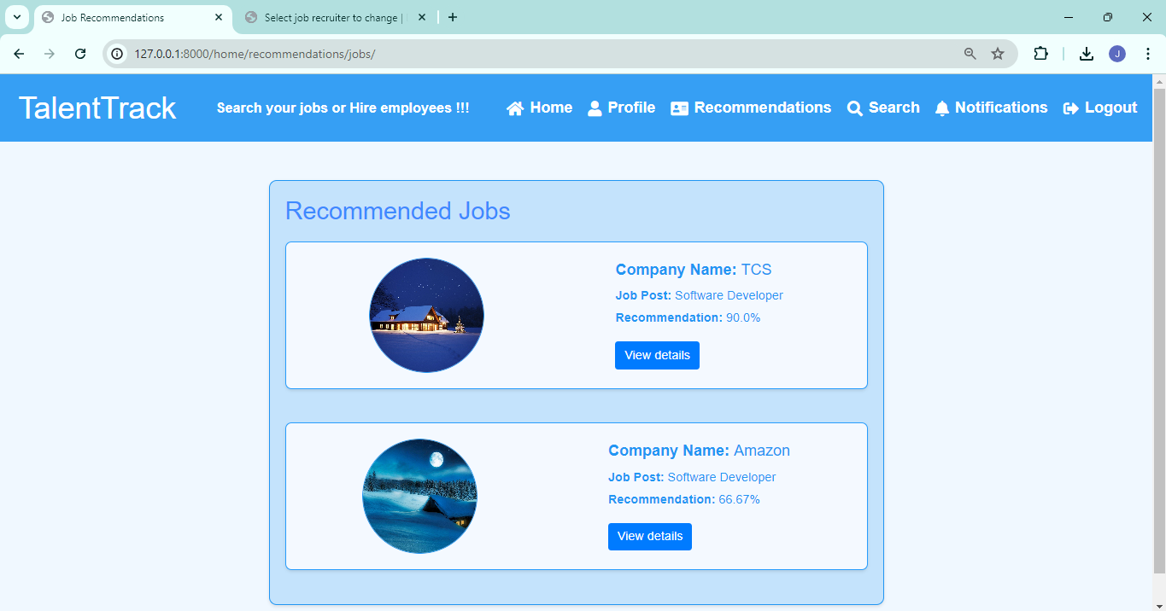

View details :

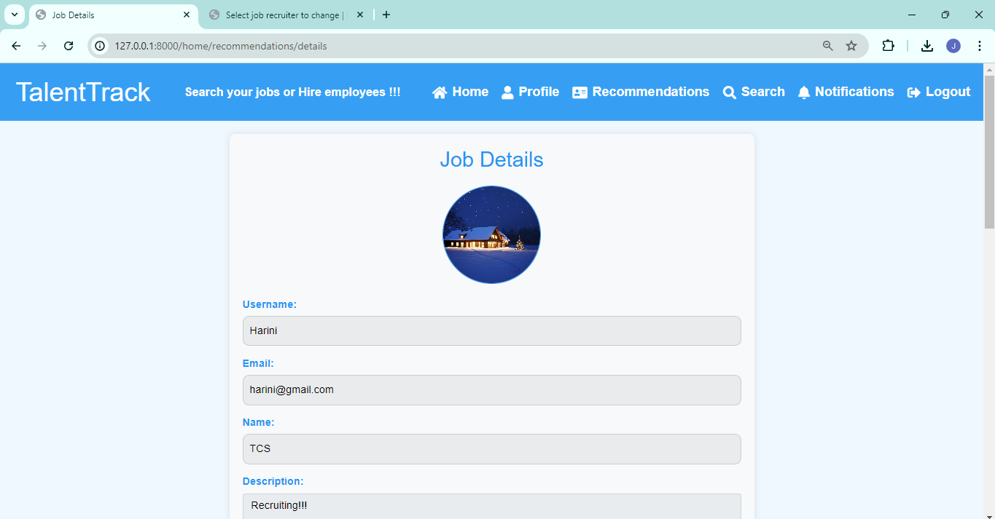

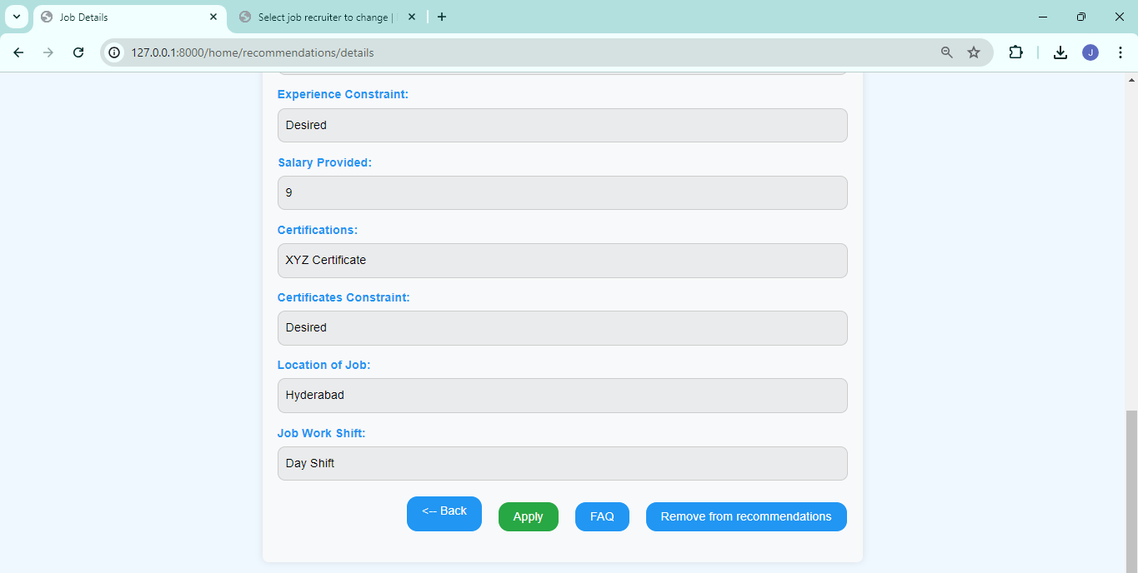

Search Jobs :

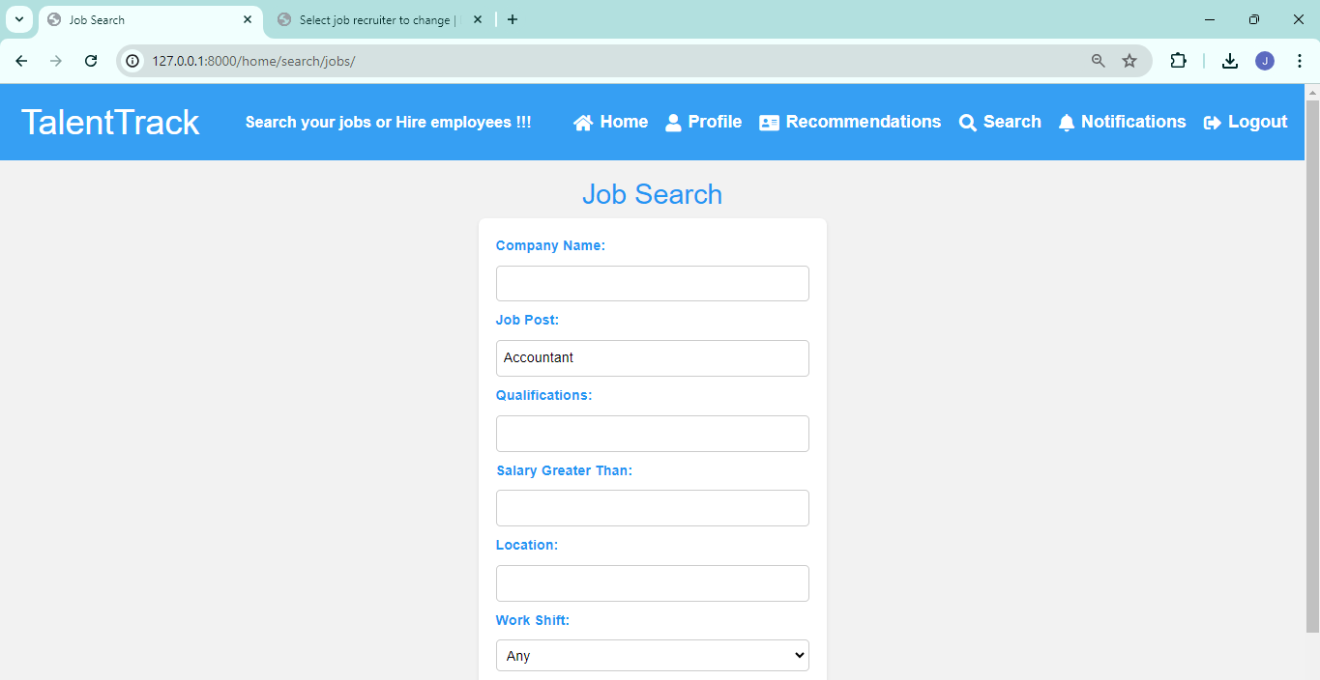

Search Results :

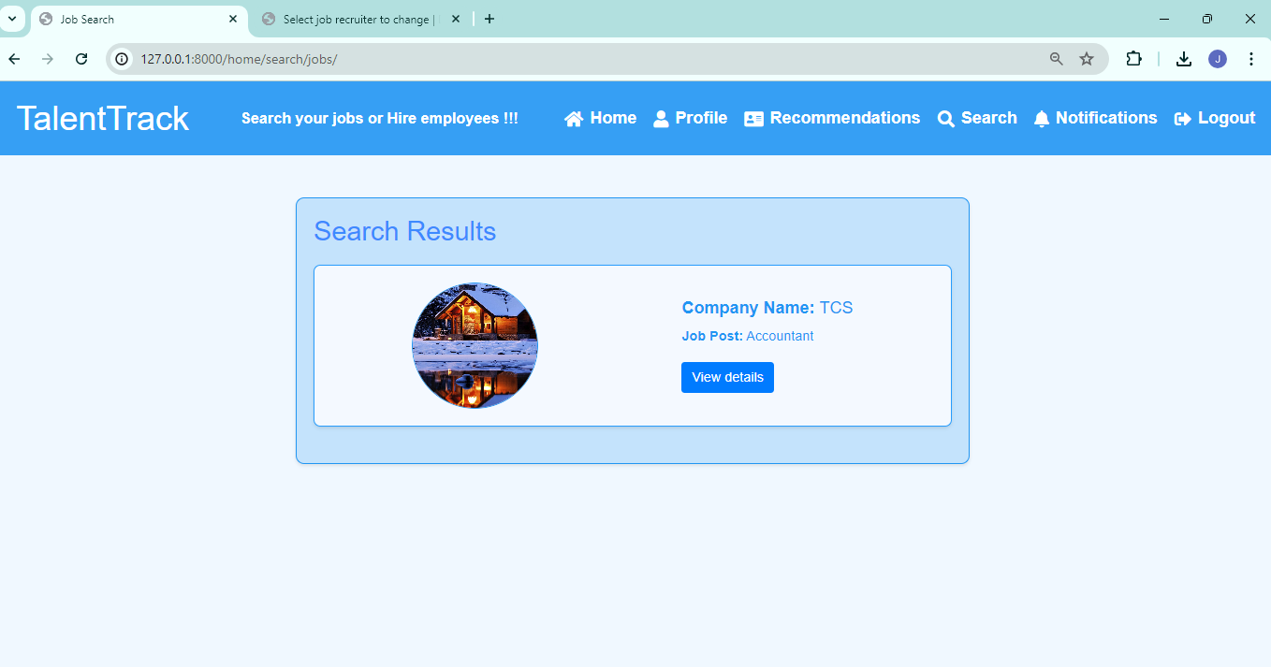

Notifications :

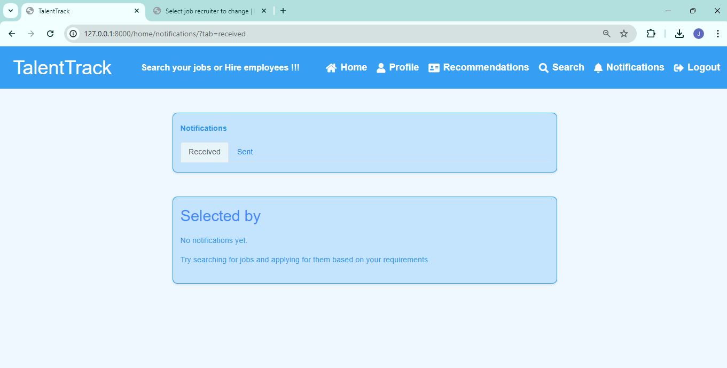

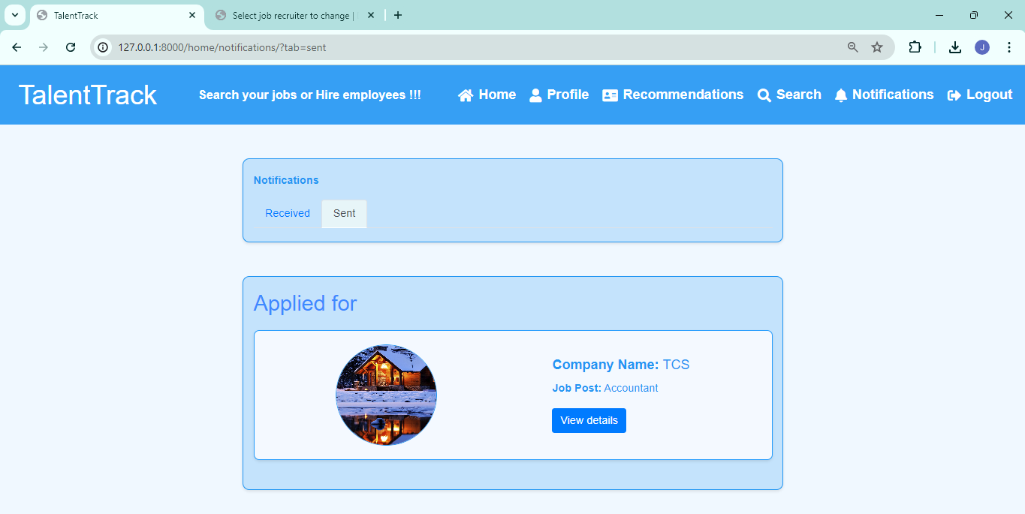

**8. Limitations of the solution provided :**

1. Lack of Google Authentication:

- The platform does not include Google authentication, which limits users to standard registration and login methods. Integrating Google authentication could enhance user convenience and security by allowing them to log in using their existing Google accounts.

2. Portal-Only Notifications:

- Users can view notifications only within the portal. Notifications are not sent to their emails, which may lead to users missing important updates if they are not regularly checking the portal.

3. No Feedback Mechanism:

- The system currently lacks a feedback mechanism, meaning users cannot provide feedback on their experience. Implementing a feedback system would help in gathering valuable user insights to improve the platform.

4. Limited Integration with External Job Platforms:

- While the platform includes match, search, notifications, FAQ, and profile management modules, it does not integrate with external job platforms. Integration with platforms like LinkedIn, Indeed, or Glassdoor could expand the reach of job postings and enhance job matching by providing more opportunities for users.

5. No Direct Communication Channel:

The platform does not provide ways for direct communication between job seekers and recruiters. Adding features such as messaging or chat would facilitate more efficient and immediate interactions, improving the overall recruitment experience.

**9. Observations from the Societal, Legal, Environmental and Ethical perspectives:**

**Equal Opportunity:**

Ensuring equal opportunity for all job seekers regardless of their background, gender, race, ethnicity, religion, or any other characteristic is essential. The platform should avoid any discriminatory practices in job matching and recruitment processes to promote fairness and inclusivity in the job market.

**Privacy Protection:**

Respecting the privacy of job seekers' personal information and data is paramount. The platform must adhere to strict privacy policies and regulations to safeguard sensitive information such as resumes, contact details, and employment history. Consent should be obtained before sharing any personal data with recruiters or third-party entities.

**Transparency:**

Maintaining transparency in job matching algorithms and processes is crucial to building trust among users. Job seekers and recruiters should understand how matches are made and the criteria used in the selection process. Transparency also includes disclosing any fees or charges associated with using the platform.

**Anti-discrimination:**

The platform must actively prevent discrimination in job matching based on protected characteristics. Algorithms and processes should be carefully designed and regularly monitored to identify and mitigate biases that could lead to unfair treatment of certain groups of job seekers.

**Compliance with Employment Laws:**

Adhering to local and international employment laws and regulations is essential. This includes compliance with anti-discrimination laws, minimum wage requirements, employment eligibility verification, and other labor standards. Failure to comply with these laws could result in legal liabilities and reputational damage.

**Ethical Job Posting:**

Job postings should accurately represent the job requirements, responsibilities, and compensation to ensure transparency and fairness to job seekers. Misleading or deceptive job postings can lead to dissatisfaction among applicants and damage the reputation of both recruiters and the platform.

**Protection Against Exploitation:**

Preventing exploitation of vulnerable job seekers, such as interns, entry-level workers, or individuals in precarious employment situations, is crucial. The platform should prohibit postings that promote exploitative practices, such as unpaid internships, unpaid trial work, or unsafe working conditions

**10. Learning Outcomes**

**Understanding of Recruitment Processes:** Gained deep insights into the complexities of job matching and recruitment by simulating real-world scenarios.

**Collaboration and Teamwork:** Emphasized effective collaboration and communication, coordinating tasks, and leveraging team strengths to achieve goals.

**Problem-Solving and Critical Thinking:** Fostered critical thinking and creative problem-solving by addressing the needs of job seekers and recruiters and designing appropriate solutions.

**Project Management:** Acquired practical project management experience, including planning, organizing, and executing tasks within set timelines.

**User Experience Design:** Gained experience in designing user-friendly interfaces, crucial for creating an intuitive and engaging platform. Encountered various kinds of errors during the design phase and learnt how to resolve different kinds of error thereby improving our debugging skills.

**11. References**

**11.1. Articles**

Allen, D., Mahto, R., & Otondo, R. (2007). Web-based recruitment: Effects of information, organizational brand, and attitudes toward a Web site on applicant attraction. Journal of Applied Psychology, 92(6), 1696–1708. doi:10.1037/0021-9010.92.6.1696

Cober, R., Brown, D., Keeping, L., & Levy, P. (2004). Recruitment on the net: How do organizational web site characteristics influence applicant attraction? Journal of Management, 30(5), 623–646.

**11.2. Web Sites**

Job Portal System

https://www.slideshare.net/shahsmzh/online-job-portal-uml-diagrams

Online Job Portal UML Diagrams

https://www.slideshare.net/Umang_jain/job-portal-project-documentary

Job Portal Project Documentary

https://www.slideshare.net/tawseef_sofi/virtual-job-portal-system

Virtual Job Portal System

LinkedIn Talent Solutions. (2023). "How LinkedIn Matches Job Seekers and Recruiters." Retrieved from https://business.linkedin.com/talent-solutions